ACCIDENT CAUSATION / INVESTIGATION FLOW CHART

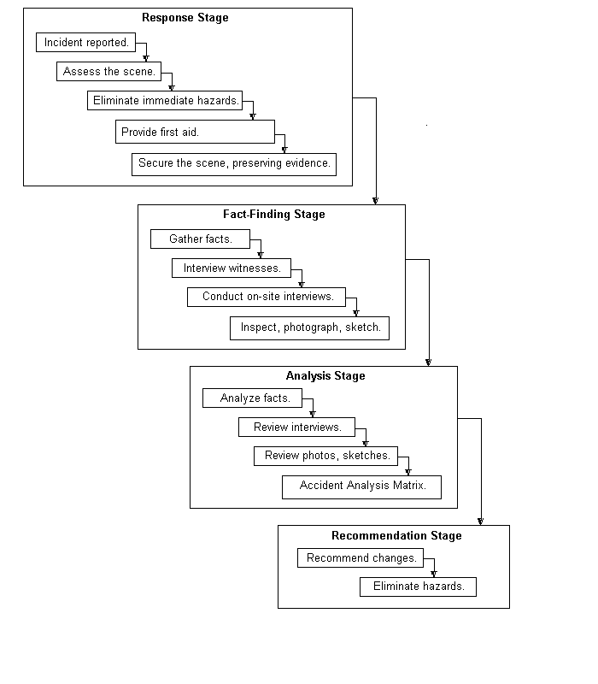

ACCIDENT CAUSATION / INVESTIGATION MODEL

The Accident Causation/Investigation Model is based on the premise that accidents are most often the result of multiple causes, employee error being but one possible cause. This investigation model utilizes a systematic approach to examine the chain of events that led to the accident in question to determine what factors (environment, training, procedure, equipment, design, and people) contributed to the accident. The ultimate goal of the process is to identify the cause(s) of the accident and to eliminate the hazard(s), thus preventing recurrence.
The investigation model incorporates four stages – the Response Stage, the Fact-Finding Stage, the Analysis Stage and the Recommendation Stage. Each of the stages can be defined as follows:
The Response Stage
- The incident/accident is reported.
- Assess the incident/accident scene for hazards.
- Look for immediate hazards.
- Alert others, if necessary, including calling for emergency services.
- Eliminate or secure immediate hazards.
- Provide first aid.
- Secure the scene, preserving any and all evidence relating to the incident/accident.
The Fact-Finding Stage

- Interview witnesses and participants, including injured individuals, if possible.
- Interview each person independently of each other.
- Retain a separate statement from each witness.
- Objectively, answer the following questions with facts, details and recommendations in mind:
- Who?
- Where?
- What?
- Why?
- When?
- How?
- Examine the area, materials, equipment and environment surrounding the incident/accident. Keep in mind that environmental conditions include weather, lighting, dust and noise.
- Take photographs, draw diagrams and draw sketches, keeping a sense of scale and providing references such as:
- North arrow on diagrams.
- A person in photographs.
- Check to determine if “best practices” were being used.
- Review relevant records such as:
- Pre-operational records.
- Pre-shift records.
- Equipment logs.
- Vehicle condition reports.
- Training records and documentation.
- Discipline yourself to fact-finding, not fault-finding.
Analysis Stage
- Assemble a team (Accident Review Board) to review the information gathered. The team should include the following employees, supervisors and managers:
- Plant Manager.
- Safety manager (as needed).
- Injured/involved party.
- Co-worker(s).
- Maintenance personnel (as needed).
- Division safety director (as needed).
- Corporate safety director (as needed).
- Regional president (as needed).
- Review the findings.
- Assign individual aspects of the findings to the “Accident Analysis Matrix Form” in order to complete the accident cause analysis.
- Determine discreet factors to be assigned as direct, indirect or contributory.
- Determine which failure mode column to assign each factor.
- Total the points and calculate percentage of contributory potential for each factor.
Recommendation Stage
- Make recommendations to change some aspect of the system to eliminate the hazard(s), based on the results indicated in the matrix.
- Eliminate hazard(s) based on recommendations.

